LAB SKILL 2
NAME: LEE XUAN HUI
MATRIC NO.:A24DW0423

INSTRUCTIONS
Answer all questions. Screenshot your coding and output and paste inside this word answer template.

QUESTION 1
Scenario:
You are tasked with creating a simple program to manage a list of students and their grades. The program will read student data from a file, process the data, and then output the results to another file.

Tasks:
Task 1: Reading from a File
Create a text file named students.txt that contains the names and grades of several students. Each line should have the format: Name Grade (e.g., John 85). Write a C++ program that reads the content of students.txt and stores the names and grades in appropriate variables. The program should display the contents of the file on the console.

Task 2: Processing Data
Modify the program to calculate the average grade of all students.
Display the average grade on the console.

Task 3: Writing to a File
Modify the program to write the names and grades of all students to a new file called output.txt. In addition to the names and grades, the program should append the average grade to the end of the output.txt file.

Task 4: Error Handling
Ensure that your program checks if the file students.txt exists before attempting to read from it. If the file does not exist, display an error message. Similarly, ensure that your program successfully opens output.txt for writing. If it cannot open the file, display an error message.

Submission Requirements:
- Paste all related screenshots including coding and outputs as provided by the tasks.
- Ensure that your code is well-commented.

CODING
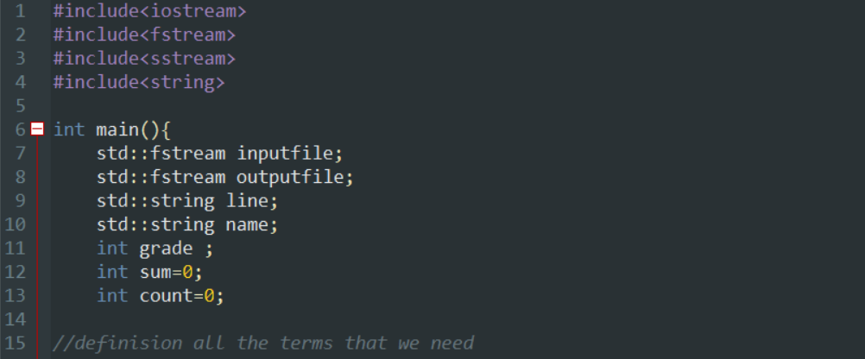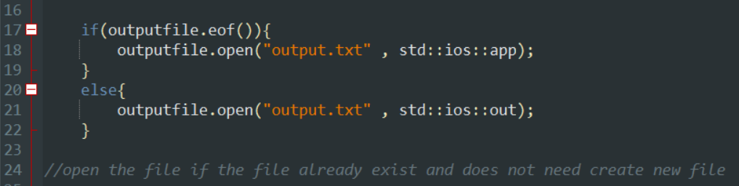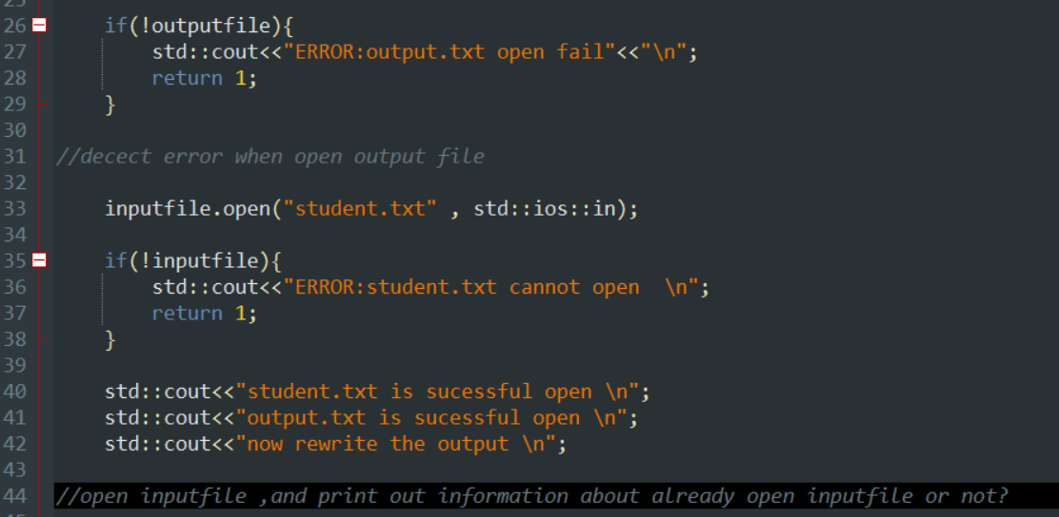
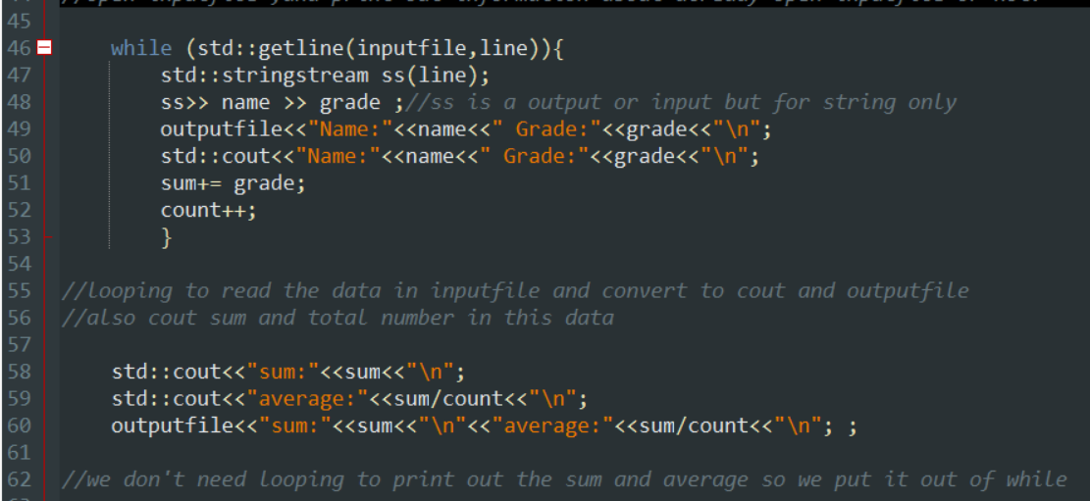
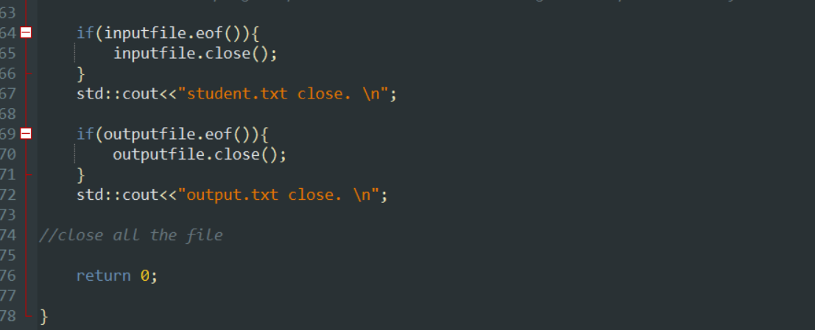
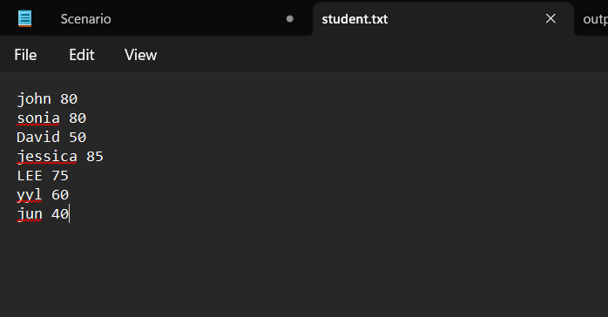

OUTPUT
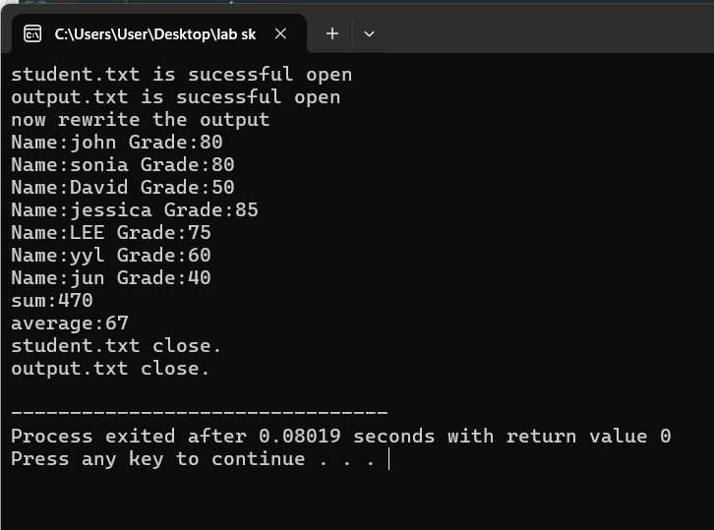
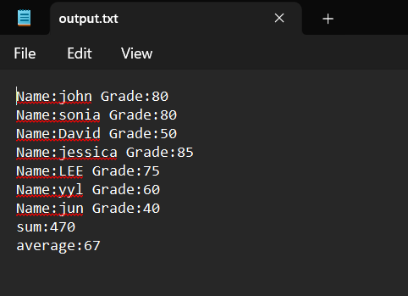

QUESTION 2
Write a C++ program that asks the user to input two numbers and choose an operation (+, -, *, /). Use a combination of if...else and switch statements to perform the operation and display the result. Ensure that your program handles division by zero appropriately.
CODING
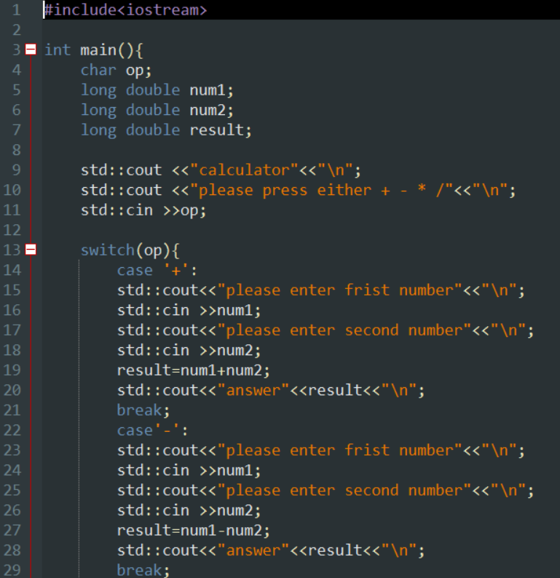
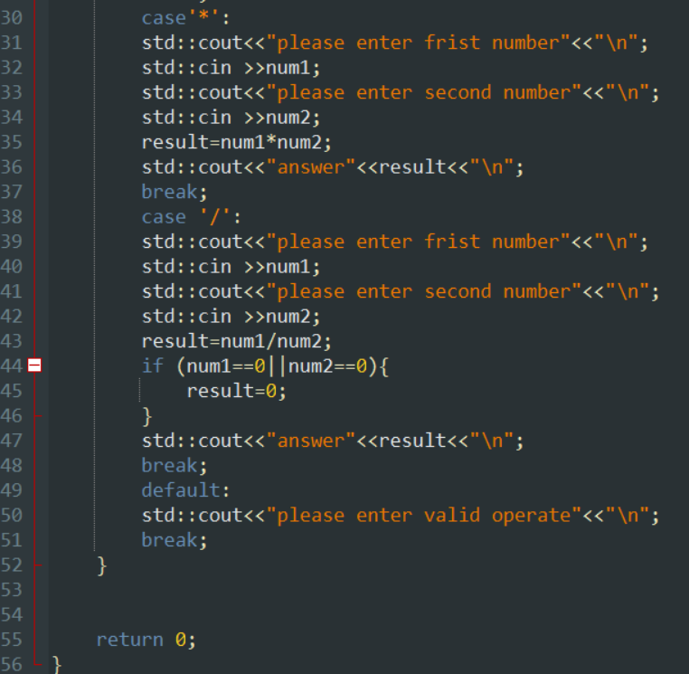

OUTPUT
